SIMATS ENGINEERING
ASSESSMENT TOOL 1 – High (Coding Challenge)
COURSE CODE: CSA09 COURSE NAME: Programming in Java
COURSE OUTCOME COVERED
CO1: Apply object-oriented programming principles such as classes, objects, encapsulation,data hiding, inheritance, and polymorphism to design and implement entity manipulations(BL3,BL4)
QUESTIONS: 10 Total Marks: 100
ANNEXURE A Coding Challenge
Code of Conduct:
I D.MANOBHIRAM(192311260) (Name / Reg No) certify that this submission is my original work and that I have adhered to the guidelines specified for this assessment. Iunderstand that any violation of academic integrity rules will result in disciplinaryaction.
Signature of the student: D.MANOBHIRAM
RUBRICS FOR CALCULATION:
Criteria | Level 4  (Exemplary) | Level 3  (Proficient) | Level 2  (Developing) | Level 1  (Beginning)
Problem
Understanding
Algorithm
Code
Implementation
Competitive
Performance
Test Case
Handling

1. Library Book Management using Classes & Encapsulation
import java.util.Scanner;
class Book {
private int id;
private String title;
private boolean issued;
Book(int id, String title) {
this.id = id;
this.title = title;
issued = false; }
int getId() {
return id; }
void issue() {
if (!issued) {
issued = true;
System.out.println("Book Issued");
} else
System.out.println("Already Issued");
} void returnBook() {
if (issued) {
issued = false;
System.out.println("Book Returned");
} else
System.out.println("Book Not Issued"); }
void display() {
System.out.println(id + " " + title + " " + (issued ? "Issued" : "Available")); }}public class LibraryManagement {
public static void main(String[] args) {
Scanner sc = new Scanner(System.in);
Book[] b = new Book[10];
int n = 0, ch, id;
do {
System.out.println("\n1.Add 2.Display 3.Issue 4.Return 5.Search 6.Exit");
System.out.print("Choice: ");
ch = sc.nextInt();
switch (ch) {
case 1:
System.out.print("Book ID: ");
id = sc.nextInt();
sc.nextLine();
System.out.print("Title: ");
String title = sc.nextLine();
b[n++] = new Book(id, title);
break;
case 2:
for (int i = 0; i < n; i++)
b[i].display();
break;
case 3:
System.out.print("Book ID: ");
id = sc.nextInt();
for (int i = 0; i < n; i++)
if (b[i].getId() == id)
b[i].issue();break;
case 4:
System.out.print("Book ID: ");
id = sc.nextInt();
for (int i = 0; i < n; i++)
if (b[i].getId() == id)
b[i].returnBook();
break;
case 5:
System.out.print("Book ID: ");
id = sc.nextInt();
for (int i = 0; i < n; i++)
if (b[i].getId() == id)
b[i].display();
break;
case 6:
System.out.println("Thank You");
break;
default:
System.out.println("Invalid Choice");
}} while (ch != 6);
sc.close();}}
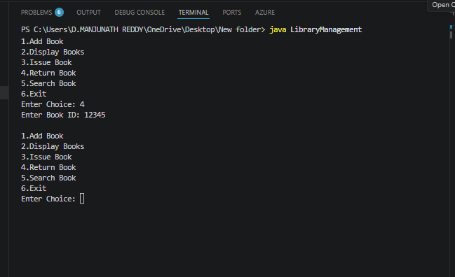
2. Employee Payroll System using Inheritance
class Employee {
int id;
String name;
Employee(int id, String name) {
this.id = id;
this.name = name;
}
double calculateSalary() {
return 0;
}
void display() {
System.out.println("ID: " + id);
System.out.println("Name: " + name);
System.out.println("Salary: $" + calculateSalary());
}
}
class PermanentEmployee extends Employee {
double basic;
PermanentEmployee(int id, String name, double basic) {
super(id, name);
this.basic = basic;
}
@Override
double calculateSalary() {
return basic + basic * 0.20;
}}
class ContractEmployee extends Employee {
int hours;
double rate;
ContractEmployee(int id, String name, int hours, double rate) {
super(id, name);
this.hours = hours;
this.rate = rate;
}
@Override
double calculateSalary() {
return hours * rate;
}}
public class PayrollSystem {
public static void main(String[] args) {
Employee e1 = new PermanentEmployee(101, "John", 50000);
Employee e2 = new ContractEmployee(102, "David", 120, 500);
e1.display();
System.out.println();
e2.display();
}}
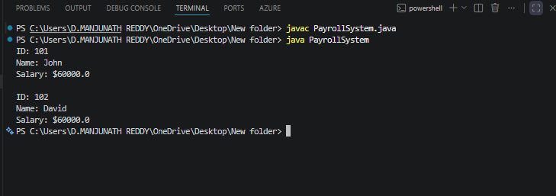

3. Vehicle Rental System using Runtime Polymorphism
class Vehicle {
String name;
Vehicle(String name) {
this.name = name;
}
double calculateRent(int days) {
return 0;
}
void bill(int days) {
System.out.println(name);
System.out.println("Days: " + days);
System.out.println("Rent: $" + calculateRent(days));
System.out.println();
}}
class Car extends Vehicle {
Car() {
super("Car");
}
@Override
double calculateRent(int days) {
return days * 1000;
}}
class Bike extends Vehicle {

Bike() {
super("Bike");
}
@Override
double calculateRent(int days) {
return days * 400;
}
}
class Bus extends Vehicle {
Bus() {
super("Bus");
}
@Override
double calculateRent(int days) {
return days * 2500;
}}
public class VehicleRental {
public static void main(String[] args) {
Vehicle[] vehicles = {
new Car(),
new Bike(),
new Bus()
};
int days = 5;
for (Vehicle v : vehicles) {
v.bill(days);
}}
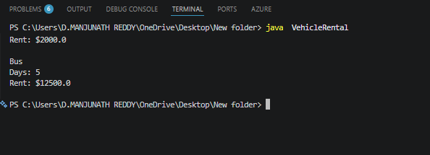

4.Bank Account System using Data Hiding
import java.util.Scanner;
class BankAccount {
private int accNo;
private String name;
private double balance;
BankAccount(int accNo, String name, double balance) {
this.accNo = accNo;
this.name = name;
this.balance = balance;
}
void deposit(double amount) {
balance += amount;
System.out.println("Amount Deposited");
}
void withdraw(double amount) {
if (amount <= balance) {
balance -= amount;
System.out.println("Amount Withdrawn");
} else {
System.out.println("Insufficient Balance");
} }
void display() {
System.out.println("Account No : " + accNo);
System.out.println("Name : " + name);
System.out.println("Balance : " + balance);
}
}
public class Main {
public static void main(String[] args) {
Scanner sc = new Scanner(System.in);
BankAccount b = new BankAccount(101, "Ravi", 5000);
System.out.print("Enter Deposit Amount: ");
b.deposit(sc.nextDouble());
System.out.print("Enter Withdraw Amount: ");
b.withdraw(sc.nextDouble());
b.display();
sc.close();
}
}
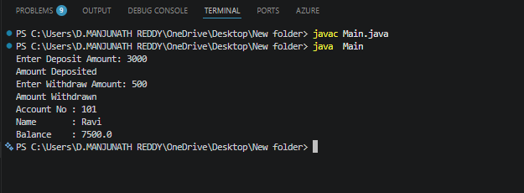

5. University Admission System using Method Overloading
class Admission {
void calculateFee() {
System.out.println("UG Fee : 50000");
}
void calculateFee(int pg) {
System.out.println("PG Fee : 70000");
}
void calculateFee(String scholarship) {
System.out.println("Scholarship Fee : 20000");
}
}
public class Main {
public static void main(String[] args) {
Admission a = new Admission();
a.calculateFee();
a.calculateFee(1);
a.calculateFee("Yes");
}
}
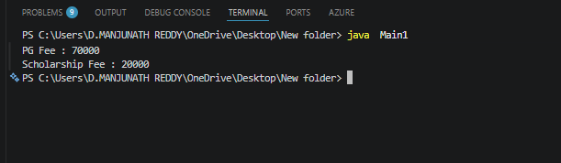
6. Shape Area Calculator using Abstract Class & Polymorphism
abstract class Shape {
abstract void area();
}
class Circle extends Shape {
double r = 5;
void area() {
System.out.println("Circle Area = " + (3.14 * r * r));
}
}

class Rectangle extends Shape {
int l = 4, b = 6;
void area() {
System.out.println("Rectangle Area = " + (l * b));
}
}

class Triangle extends Shape {
int base = 4, height = 8;
void area() {
System.out.println("Triangle Area = " + (0.5 * base * height));
}

}

public class Main2 {
public static void main(String[] args) {

Shape[] s = {
new Circle(),
new Rectangle(),
new Triangle()
};

for (Shape x : s)
x.area();
}
}
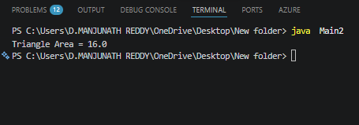

7. Hospital Management System using Interfaces
interface MedicalRecord {
void addRecord();
void displayRecord();
}
class Patient implements MedicalRecord {
String name = "Rahul";
int age = 20;
public void addRecord() {
System.out.println("Patient Record Added");
}
public void displayRecord() {
System.out.println("Patient Name : " + name);
System.out.println("Age : " + age);
}
}
class Doctor implements MedicalRecord {
String name = "Dr. Kumar";
String dept = "Cardiology";

public void addRecord() {
System.out.println("Doctor Record Added");
}

public void displayRecord() {
System.out.println("Doctor Name : " + name);
System.out.println("Department : " + dept);
}
}
public class Main {
public static void main(String[] args) {
MedicalRecord p = new Patient();
MedicalRecord d = new Doctor();

p.addRecord();
p.displayRecord();

System.out.println();

d.addRecord();
d.displayRecord();
}
} 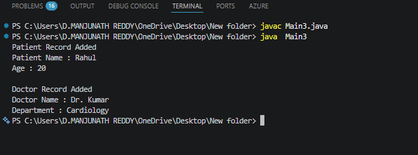
8. Online Shopping Order System using Packages
class Product {
String name;
double price;
Product(String name, double price) {
this.name = name;
this.price = price;
}}
class Order {
void bill(Product p, int qty) {
double total = p.price * qty;
System.out.println("Product : " + p.name);
System.out.println("Price : " + p.price);
System.out.println("Quantity : " + qty);
System.out.println("Total : " + total);
}}
public class Main {
public static void main(String[] args) {
Product p = new Product("Laptop", 50000);
Order o = new Order();
o.bill(p, 2);
}}
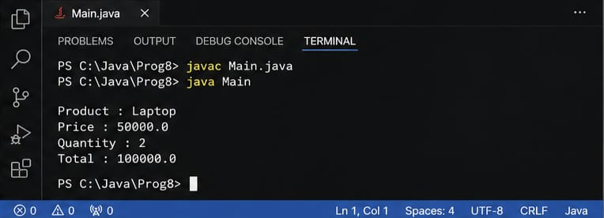
9. Student Result Analyzer using Arrays of Objects
class Student {
int roll, String name, int m1, m2, m3;
Student(int r, String n, int a, int b, int c) {
roll = r;
name = n;
m1 = a;
m2 = b;
m3 = c;
}
int total() {
return m1 + m2 + m3;
}
double average() {
return total() / 3.0;
}
String grade() {
if (average() >= 90)
return "A";
else if (average() >= 75)
return "B";
else if (average() >= 50)
return "C";
else
return "Fail";
}
void display() {
System.out.println(roll + " " + name);
System.out.println("Total = " + total());
System.out.println("Average = " + average());
System.out.println("Grade = " + grade());
}
}
public class Main {
public static void main(String[] args) {
Student s[] = {
new Student(1, "Rahul", 90, 80, 85),
new Student(2, "Asha", 95, 92, 91),
new Student(3, "Kiran", 70, 75, 80)
};
int max = 0;
for (int i = 0; i < s.length; i++) {
s[i].display();
System.out.println();
if (s[i].total() > s[max].total())
max = i;
} System.out.println("Class Topper : " + s[max].name);
}}
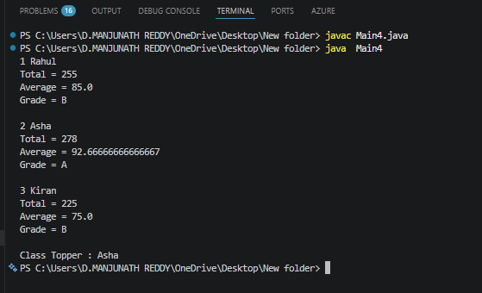
10. Smart Home Device Controller using Hierarchical Inheritance
class Device {
void on() {
System.out.println("Device ON");
}

void off() {
System.out.println("Device OFF");
}

void power() {
System.out.println("Power Consumption");
}
}

class Light extends Device {
void power() {
System.out.println("Light : 20W");
}
}

class Fan extends Device {
void power() {
System.out.println("Fan : 75W");
}
}

class AirConditioner extends Device {
void power() {
System.out.println("AC : 1500W");
}
}
public class Main {
public static void main(String[] args) {
Device d;
d = new Light();
d.on();
d.power();
d = new Fan();
d.on();
d.power();
d = new AirConditioner();
d.on();
d.power();
}
} 